Dataset Structure

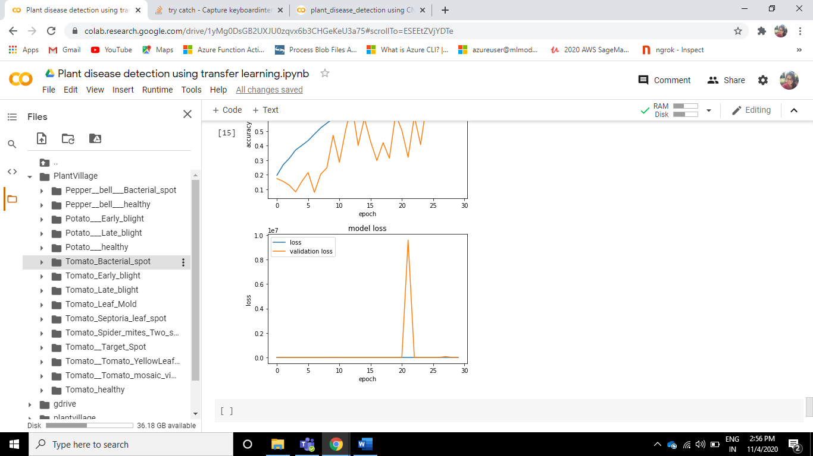

|  |  |  |
| --- | --- | --- |
| **Algorithm** | **Accuracy** | **Validation_ accuracy** |
| CNN custom | 0.9894 | 0.9789 |
| DenseNet | 0.9889 | 0.9646 |
| MobileNet | 0.8230 | 0.8052 |
| VGG 16 | 0.7025 | 0.6770 |
| VGG 19 | 0.7738 | 0.7724 |
| ResNet | .7364 | 0.6638 |

**CNN Model:**

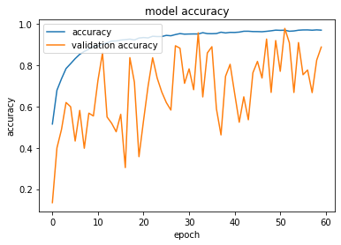 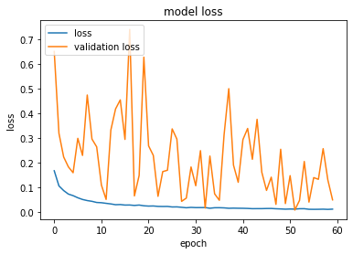 **and reguta**

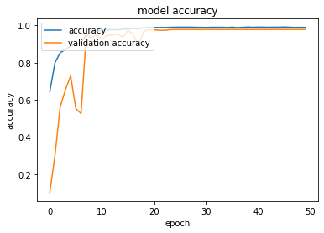 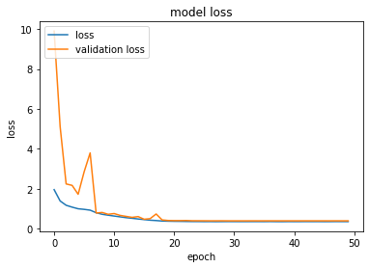**acc: 98.94 val acc: 97.80**

**DenseNet**

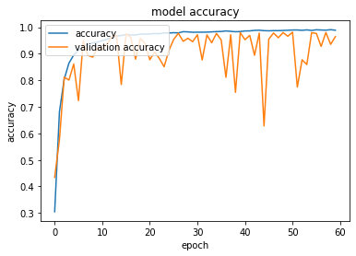 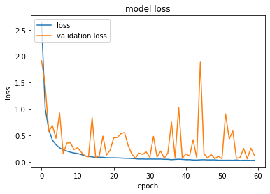 **overfitting**

**MobileNet** :

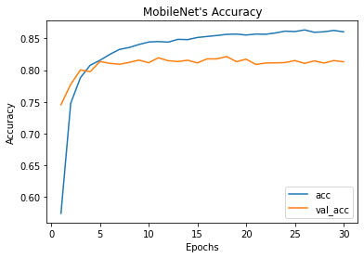 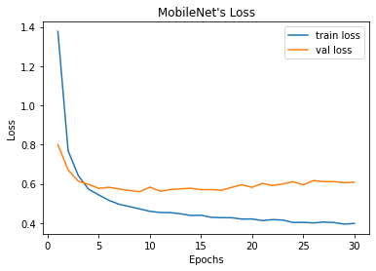 overfitting and high variance(apply regularization )

**After applying regularization**

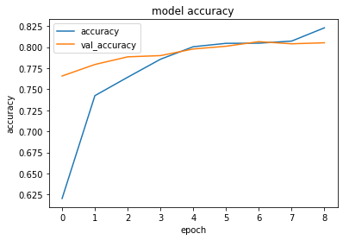 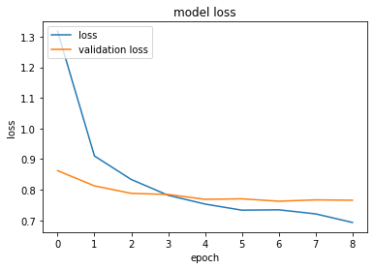

**VGG16:**

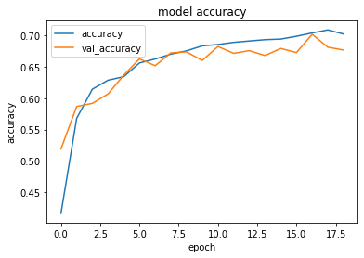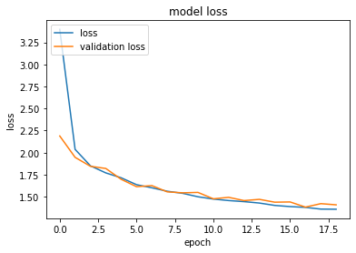

**VGG19:**

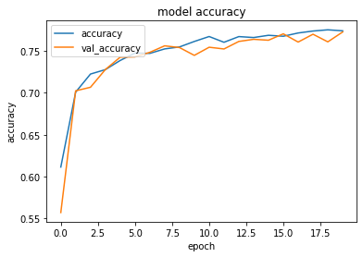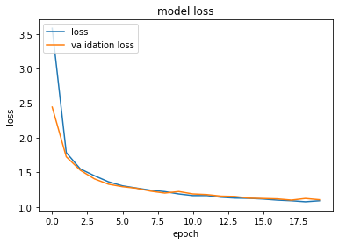

**RenNet 50:**

**Without regularizer**

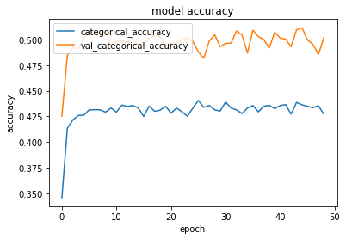 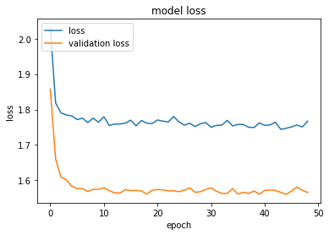

**Early stopping**

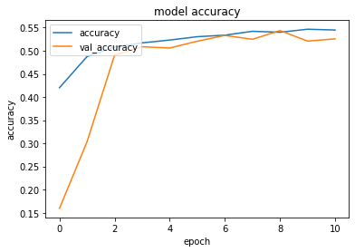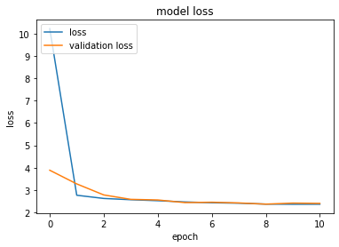

**Without Early stopping**

